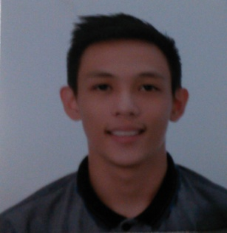

**NEIL ORVEN REYES CUETO**

Blk. 1, Lot 1, Treelane Park Subd., Putatan, Muntinlupa City

nrcueto@student.apc.edu.ph

09064817641

**EDUCATIONAL BACKGROUND:**

Tertiary

Asia Pacific College

Magallanes, Makati City

Bachelor of Science in Information Technology Major in Mobile and Internet Technology (undergraduate)

April, 2016-Present

Secondary

Parochial School of Catananuan

Catanauan, Quezon Province

2009-2013

Elementary

Parochial School of Catananuan

Catanauan, Quezon Province

2002-2009

**ORGANIZATIONS:**

* Member of Junior Philippine Computer Society (JPCS) in Asia Pacific College

**RELATED SKILLS:**

Programming Experience (HTML, Java, PHP, Web Programming)

Writing Skills (Ability to efficiently produce concise, organized reports labs and memos)

Public Speaking Skills (Memorized)

Research Writing Skills

Technical Skills (MS Word, Excel, PowerPoint, Use of Internet search engines, Email)

**CHARACTER REFERENCES:**

Ma. Aurora Cyd Baticulon

Treasurer - Parochial School of Catanauan

09399040632

Sr. Arlyn Dogillo

Tayabas, Quezon

09498293092